ASHLEY JAMES DOWIE

sit 120 aSSEMENT 1: Proposal and proof of concept

Table of Contents

Product Summary 2

Asset list 2

Product Purpose: 3

Target Audience 3

Individuals / personal use: 3

Organisations / Business: 4

User stories 4

Why Password Place is creative: 5

UX/UI Design 6

Major Components and their intended behaviour: 8

Guest mode password generation form 8

Member mode password generation form 8

System summary 12

# Product Summary

Password Place is a product which allows users to generate passwords for various applications and websites. Password place requires the user to only remember a single password, their ‘primary password”. Password Place uses a deterministic function to create unique password for each application based on the name of the applications name and the user’s primary password. Password Place does not store any user passwords, they are always generated on the fly with the deterministic function.

Password place offers two options for use. The user can choose to use Password Place without creating an account. Or the user can choose to create an account. If the user chooses to use Password Place without creating an account, they will be able to get a unique password for any application simply by typing in a password and a websites name. As the function for determining the password is deterministic, the password will be the same for the user each time.

Users that choose to create an account will have access to more advanced features. A user that signs in will be able to create new application entries and save these to a list. This means the user does not have to try and remember which applications they are using Password Place generated passwords for. Users will also be able to “step forward” and “step back” passwords. This allows passwords to be generated using a third parameter, which is a simple integer value known as “step”. Step forward allows a user to generate a new password for an application in the situation that the application has password expiration after a set time. Step back allows a user to go through the history of their passwords and recall previous passwords.

For a logged in user the only information that is stored is their sign in password, their list of applications and the current step for the application. Users are recommended to not use a primary password that is the same as their sign in password. By not storing the user’s primary password, even if someone gains access to the user’s account, they will not be able to determine any of the user’s passwords.

# Asset list

|  |  |
| --- | --- |
| style.css | The main styling sheet to be used throughout the website. This sheet uses media queries to create break points to make pages as responsive as possible. The main page layout is determined using grid areas. Other features provided by style.css include tooltips, a navigation bar and a self-contained content scrolling pane. |
| index.html | The main html page that will be used to display all the Vue templates for the application. As the first draft of this product contains no Vue files, index.HTML contains all the DOM elements directly. Index.html makes use of various Vue directives, using the Vue component within index.js called “lister”. Index.html currently only contains a demonstration for the “Member” section of the product. Some elements in index.html make use of inline CSS. |
| main.js | This JavaScript file will eventually contain the required Vue imports, the main app component and router. However, as the first draft for this product contains no Vue files, main.js current just holds a Vue component called “lister”. The lister component contains all the data, methods and computed data required to make a functional demonstration of the “Member” section of the product. |

# Product Purpose:

Password Place was created to offer users the same level of password protection they would have if they used a unique password for every application. But to only require them to remember a single password.

# Target Audience

Password place targets any user who wants strong password security but want the convenience of not needing to memorise a unique password for every application they use. This product could appear to larger organisations or individuals alike.

Password place can be used for generating passwords for entertainment purposes such as Netflix or for business purposes such as generating passwords for products such as MYOB. The only limitation of Password Place is that passwords are determined by the application, so users would need to be willing to change their existing passwords to make use of the app. This could also potentially not suit some purposes such as an organisations security codes that may be required to be predetermined by the entity.

Individuals / personal use:  
Many individuals use a single password for every application they use. This causes two problems main problems for the user. These problems are inconvenience and security risk.

The first problem is that if an application has a password expiration policy, the user is going to need to change their password for that website. The user now either has the choice of remembering an additional password each time this happens, or they will need to update their password for every application they use. Password Place offers a convenient solution for the user as they only must remember a single password. If a password for an app expires, the user simply needs to “step forward” their current password for that application and then update their password on that application only.

The second problem is that if the user uses the same password for every application, someone who discovers that password will have access to every application that the user uses. Password Place fixes this problem by ensuring that the user will have a unique password for every application that they use. If someone were to discover one of the user’s passwords, they would only have access to the one application associated with that password. Password Place does not send the user’s primary password to the server side, all processing occurs on the client side. This greatly reduces the likelihood that the user’s primary password will ever be stolen.

## Organisations / Business:

Organisations generally use a unique password for each application that they use. However, to keep track of these password they are normally stored. As the systems of larger organisations are often the target of cyber security threats, storing passwords creates a large security risk for organisations. This cannot be resolved by expecting employees to memorise a large list of unique passwords for the organisation as the number of applications an organisation uses would be prohibitive. It could be possible to have employees memorise passwords for the applications that are only immediately a part of their role, however this would create knowledge silos that pose a risk of the password being lost if the staff member were to leave the organisation. Additionally, if passwords were updated, it would be difficult to share the new password changes across the organisation without using means that pose a security threat, such as emailing the updated password.

Password Place removes the requirement and the risk of the organisation storing passwords. Organisations also do not need to be concerned about their passwords being compromised if password place were to succumb to a cyber security attack, as Password Place does not store passwords. Password Place dynamically generates passwords with a deterministic function. The only information that Password Place stores is the user’s log in password (which is not the same as their primary password), log in name and their list of applications, each having an application name and step count.

## User stories

* Russell is a small business owner within the IT industry. Russell’s business uses a lot of third-party services and applications to help meet the needs of his business as his business is too small to try and do everything in house. Russell’s business had previously been storing their passwords in an excel spreadsheet for all the third-party applications they use.   
    
  Unfortunately, Russell’s business became the victim of a cyber security attack and the passwords within the excel spreadsheet were compromised. Russell has considered having a third party with better security practices and infrastructure store his businesses passwords, however Russell is unsure if he wants to trust all his passwords with a third party. Russell would like to find a way to meet his need for maintaining many passwords without the risk that comes with storing them.
* Jenny is very active on social media and holds numerous accounts on various platforms. Jenny uses a single password for all her social media accounts. Jenny does this as it is easier to remember one password and she doesn’t want to risk forgetting a password and being locked out of one of her accounts  
    
  One day on of Jenny’s friends watched her typing in her password. Her friend later went into all of Jenny’s social media accounts and left embarrassing messages there. Jenny now realises that if she had used a unique password for every account, only one of her accounts would have been compromised. However, Jenny is not sure she can remember many passwords off the top of her head. Jenny wishes that she would only have to remember a single password and not have to worry about all her accounts being compromised again.
* John uses a lot of different applications for various things. John is conscious of internet security, so he uses several passwords for his different apps. John has all his passwords memorised and this has not caused any problems for him so far as he is confident that he can remember them all as they are ingrained in his brain. One day one of John’s passwords expires. John is in a hurry to do what he needs to on the application quickly so he can head off to work. John quickly enters a new password and then leaves for work.  
    
  A week later John decides to use the application again. John goes to enter his password and it is denied. John remembers that he changed the password last week, but he cannot remember what the password is. John is now locked out of the application. John wants a way to track the history of changes to his passwords.

# Why Password Place is creative:

Password Place is creative because it offers a solution to the three main concerns of password security. These three main concerns are external risks (passwords being compromised by a third party, internal risks (the user forgetting a password or losing the passwords they have stored) and convenience.

The use of a deterministic function greatly reduces external security threats. Passwords are not stored in neither Password Place nor on the user’s end. This means that if someone were to look through all the storage of either system, no passwords could be obtained. When Password Place generates a user’s password, this happens on the client side. This means that a user’s primary password will not be intercepted as it could be if it were sent to the server and the user’s generated password cannot be intercepted either.

By using a deterministic function to generate passwords, passwords cannot be lost. Password Place’s step feature allows users to maintain a complete record of their previous passwords. This means this even if a user needed to remember a previously used password, they can retrieve it at any time. A user cannot lose their password. So long as a user remembers their login name or their login password and their primary password, their password cannot be lost.

Password place offers great convenience to the user. The user will no longer have to remember a password for every application, yet they will gain the same benefit as they would if they did. Complex passwords can be generated even if the user’s primary password is relatively simple. Even if a password were to expire, the user can generate a new password for the app with a single click of the step button.

# UX/UI Design

Password Place is a responsive application and will attempt to optimise the layout and size of page elements to best display on different screen resolutions. The navigation bar switches between being displayed at the top or the left side of the screen based on screen width. The navigation bar will also swap between being vertical or horizontal based depending on screen width. As the screen width shrinks, Password Place attempts to make greater use of vertical space to make more room horizontally. Below is an example of the guest page of Password Place. The first image shows Password Place displayed at a mobile resolution. The image shows Password Place displayed in desktop resolution.

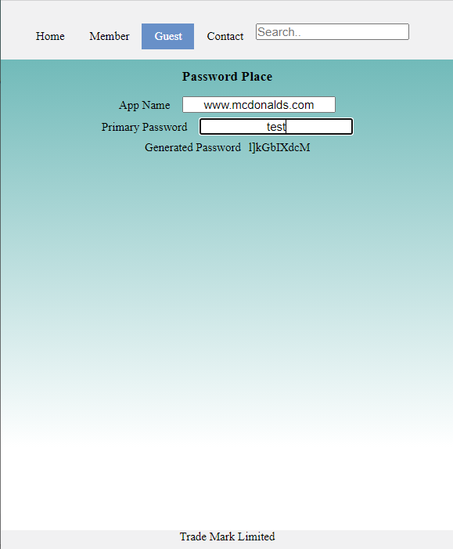

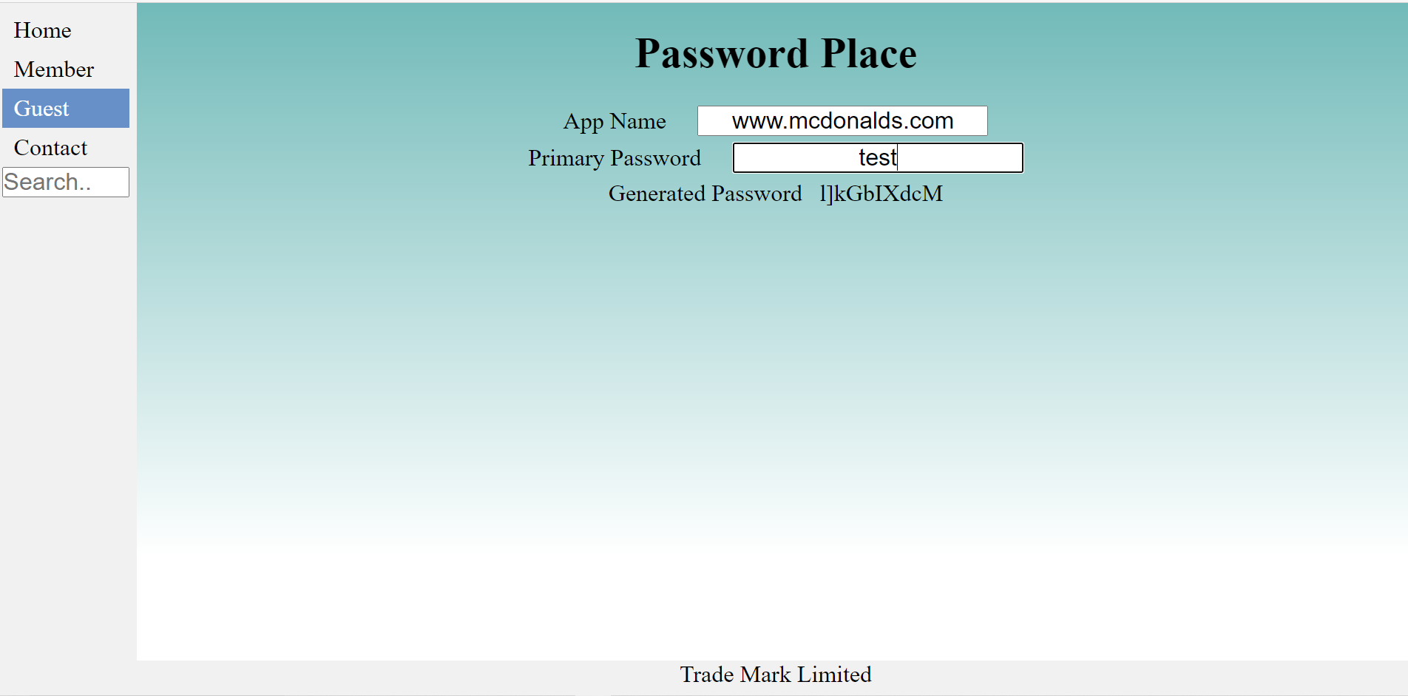

Below is an image of the Members section of the website. At the bottom you will notice a list of apps that the user has added.

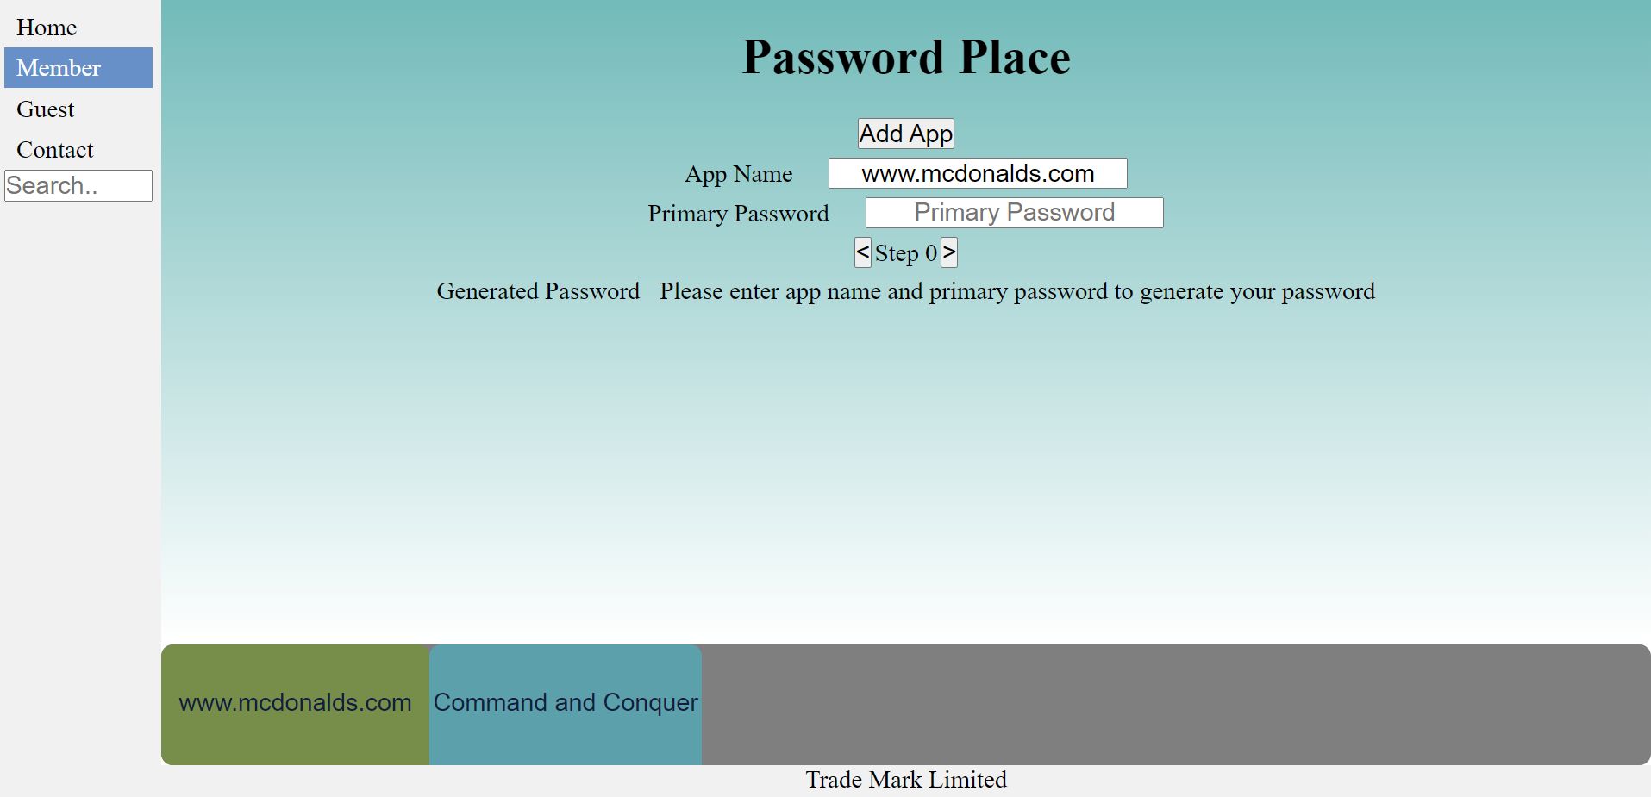

If the user were to add enough apps that the buttons could not display within the lower pane, a scroll bar will become visible. The user will then be able to scroll through the list of items, without scrolling the other sections of the page.

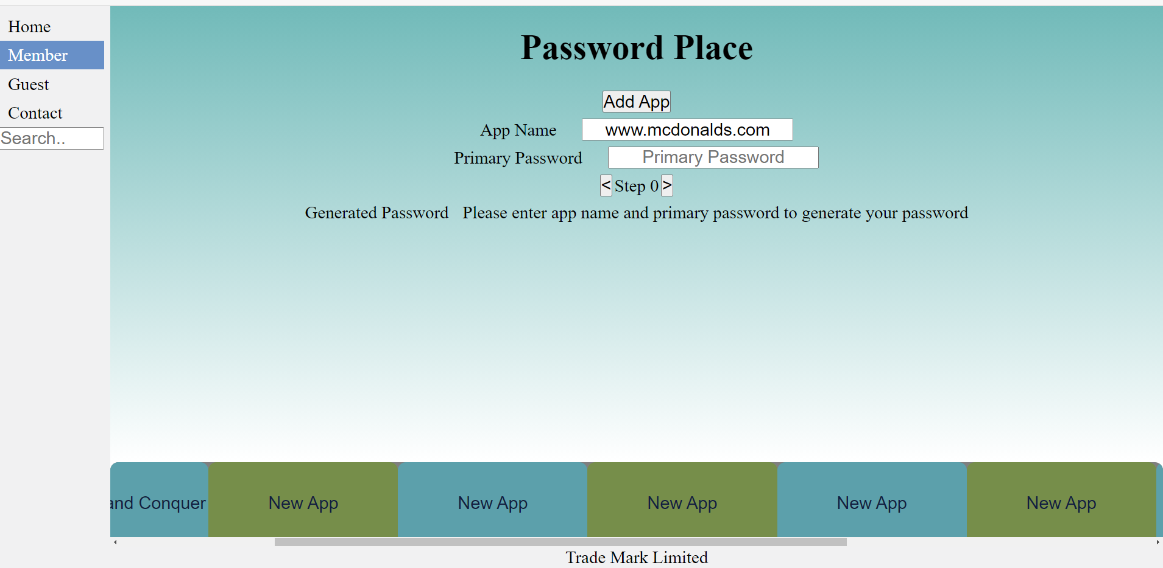

As the width of the page decreases, Password Place will reduce the amount of apps that it attempts to display.

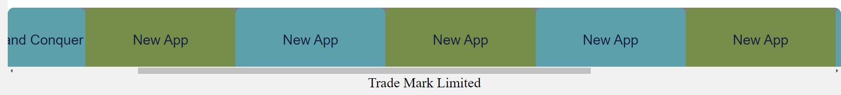

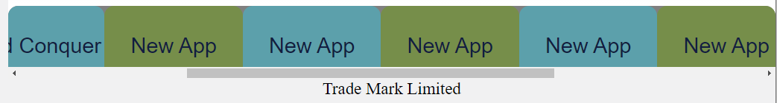

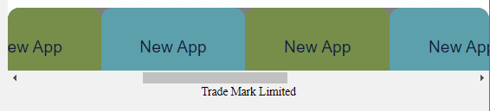

Password Place makes use of tool tips to help guide and instruct the user.

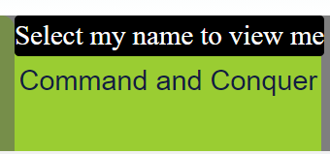

# Major Components and their intended behaviour:

## Guest mode password generation form

Below is an example of the guest mode password generation form. The form is very simple to use. To generate a password, Password Place needs two things, an application name and a primary password. The user simply needs to enter the name of the application and then their primary password. Once they have done this, a unique password will instantly be created for them.

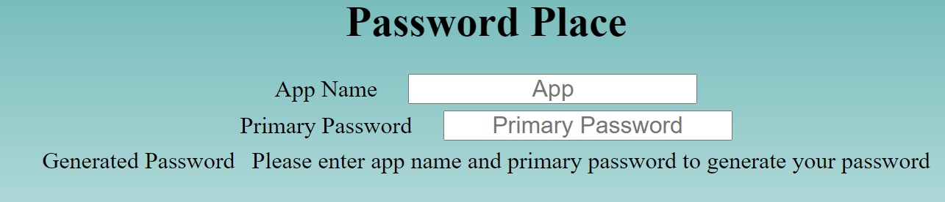

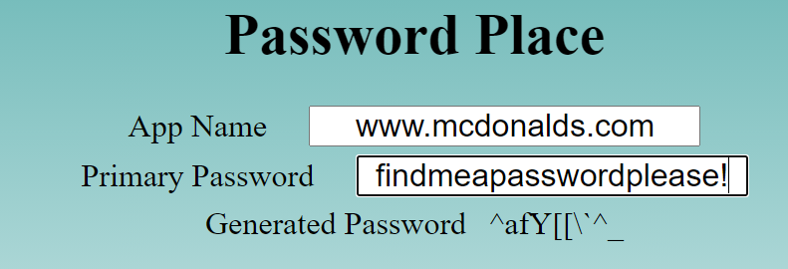

## Member mode password generation form

The Member mode password generation form offers the same base functionality as the Guest mode password generation form with a few additions. Firstly, the user is able to maintain a persistent list of all of the apps that they have generated a password for and the current “step” of that app. Users can add more apps to their list by simply select the “Add App” button. Users can also select existing apps from the list to generate a password for that application. The user can edit the information of any app that they currently have open.

Below the user is currently on the “Command and Conquer” App. All they need to do is select [www.mcdonalds.com](http://www.mcdonalds.com) from the list to select that app:  
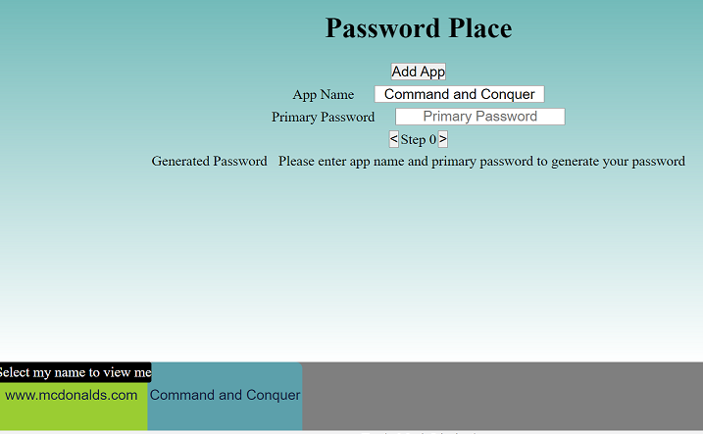

The password information will not be relevant to www.mcdonalds.com

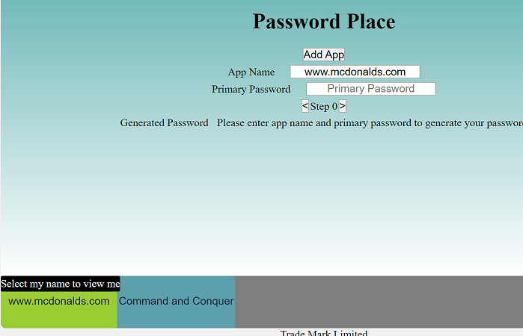

The user can easily edit the name of the selected app simply by typing in the app name input section and the apps name will instantly change to reflect this on the list.

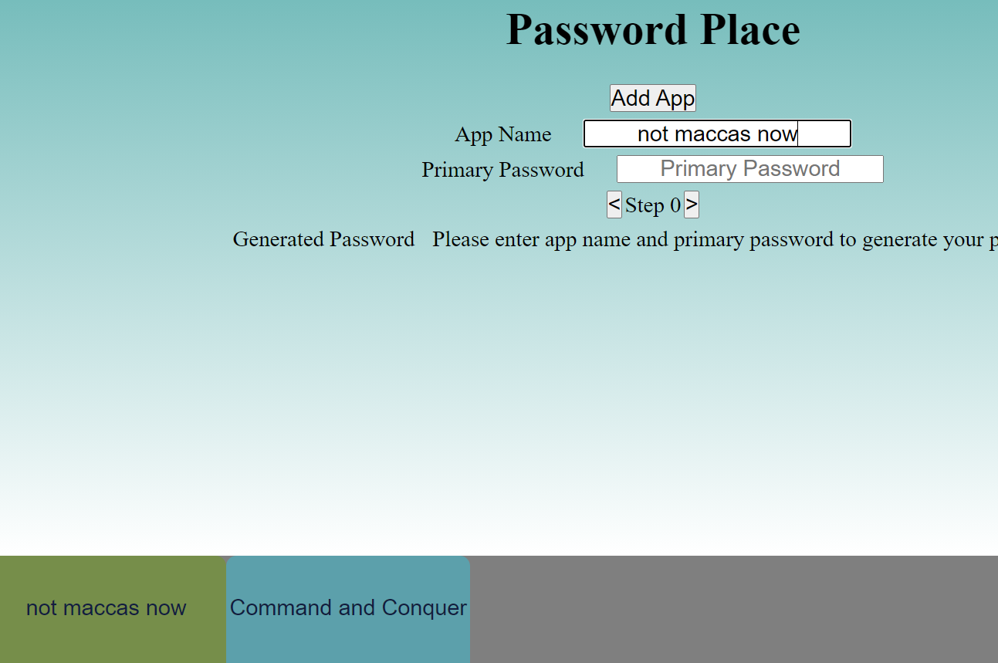

The other major feature that the Members Mode form offers is the ability to increment or decrement the apps “step” counter. The user does this simply by selecting the arrow keys next to the step value. This allows passwords to be modified in case they have expired. The user is also able to step back to see their previous password such as below:

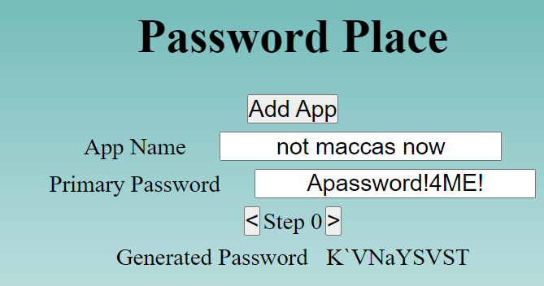

Step forward:

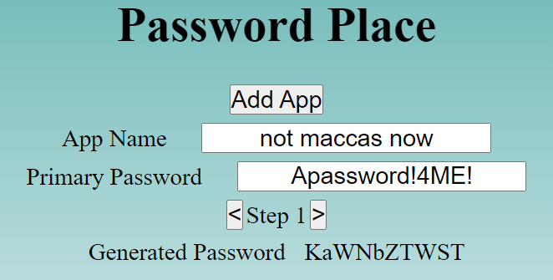

Step back:



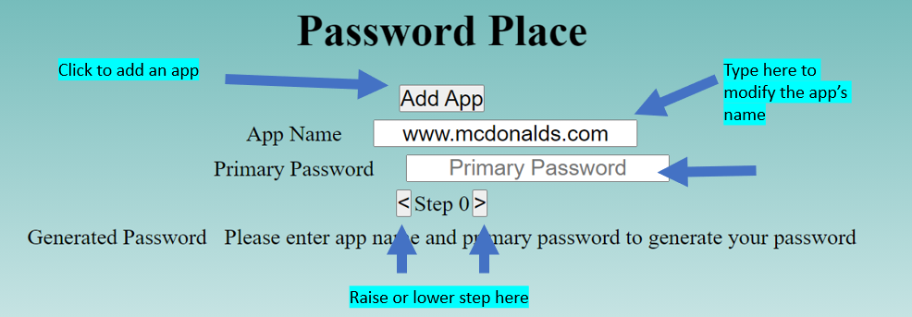

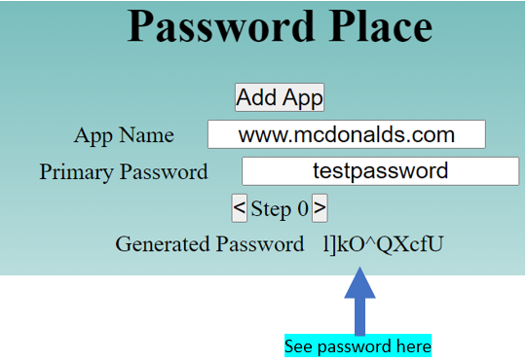

Once all the required information is entered. The generated password will be instantly displayed.

# System summary

Password place gives users the choice of two modes. Users have the choice of either using guest mode or member mode. Guest mode does not require the user to log in. However, the drawback is that the user will not have access to the step feature and will not be able to save apps to a list. Member mode allows users to save apps to a list, removing the need for them to have to enter the name of the app they wish to generate a password for each time. Member mode also allows users to make use of the step feature

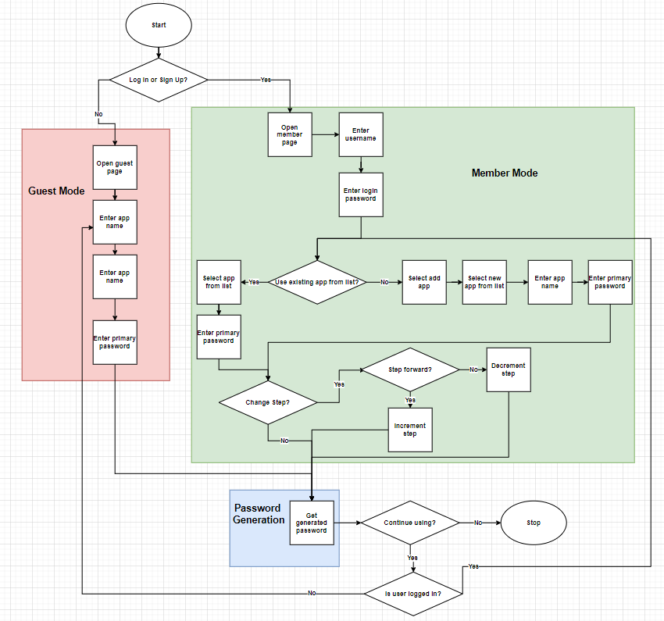

All files can be found at the following GitHub link:

https://github.com/AshleyDowie/SIT120---Introduction-To-Responsive-Web-Apps/tree/main/assignment%201/assignment%20files